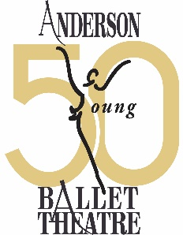

Golden Anniversary Advertising Opportunities
Business or Family Name: ___________________________________________
Billing Contact: ____________________________________________________
Address: _________________________________________________________
City/State/Zip Code: _______________________________________________
Phone: ____________________Email:_________________________________
Artwork: Please provide your artwork or company logo in pdf format or jpg format and forward to kwilliams6085@gmail.com by November 17, 2023 for The Nutcracker Program and by February 2, 2024 for the 12 Dancing Princesses Program.
_____Full Page: 5”x 8” - $750 for one program, $1,000 for both programs
_____Half Page: 5” x 4” - $500 for one program, $750 for both programs
_____Quarter Page: 2.25” x 4” - $250 for one program, $375 for both programs
Payment is due by October 15, 2023
Please make all payments to AYBT. Contact us at aybtboardofdirectors@gmail.com should you need an invoice.

_____The Nutcracker program ONLY
_____12 Dancing Princesses program ONLY
_____Advertisement in both programs (The Nutcracker & 12 Dancing Princesses)

